Computational Physics 3

HW 3

Christopher Morris

***Problem 1***

**1.i)**

**1.ii)**

***Problem 2***

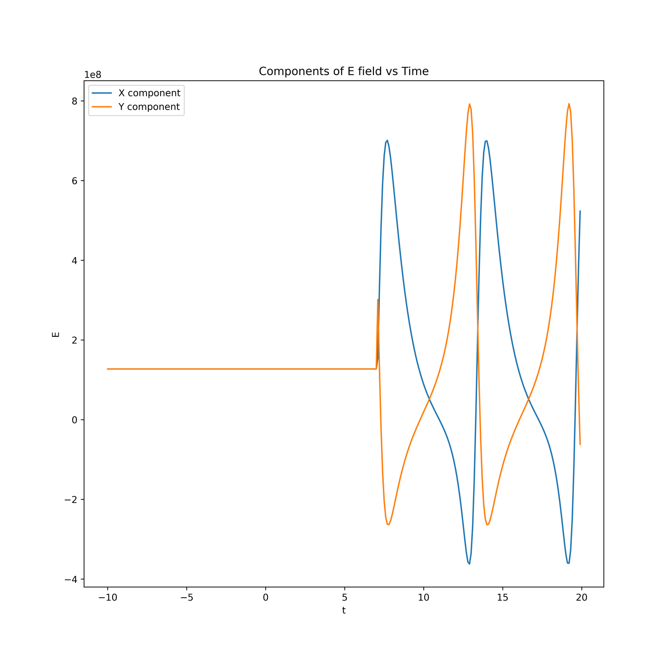

***Problem 3***

The Radial component of the electric field was calculated as: $\sqrt{{Ex}^{2}+{Ey}^{2}}$

The Tangential component of the electric field was calculated as: $\tan^{-1}{({Ey}/{Ex})}$

Where Ex, Ey are the x, y components of the electric field

**3.i)**

**3.ii)**

***Problem 4***

